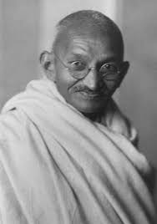 | 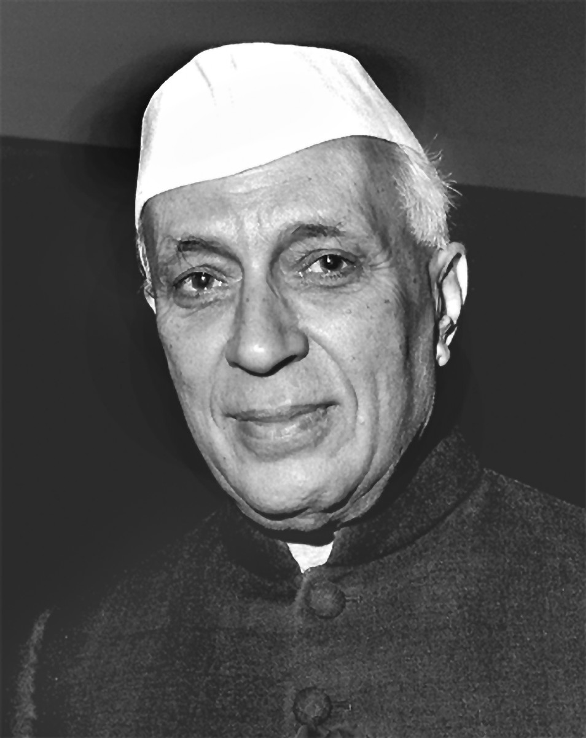 | 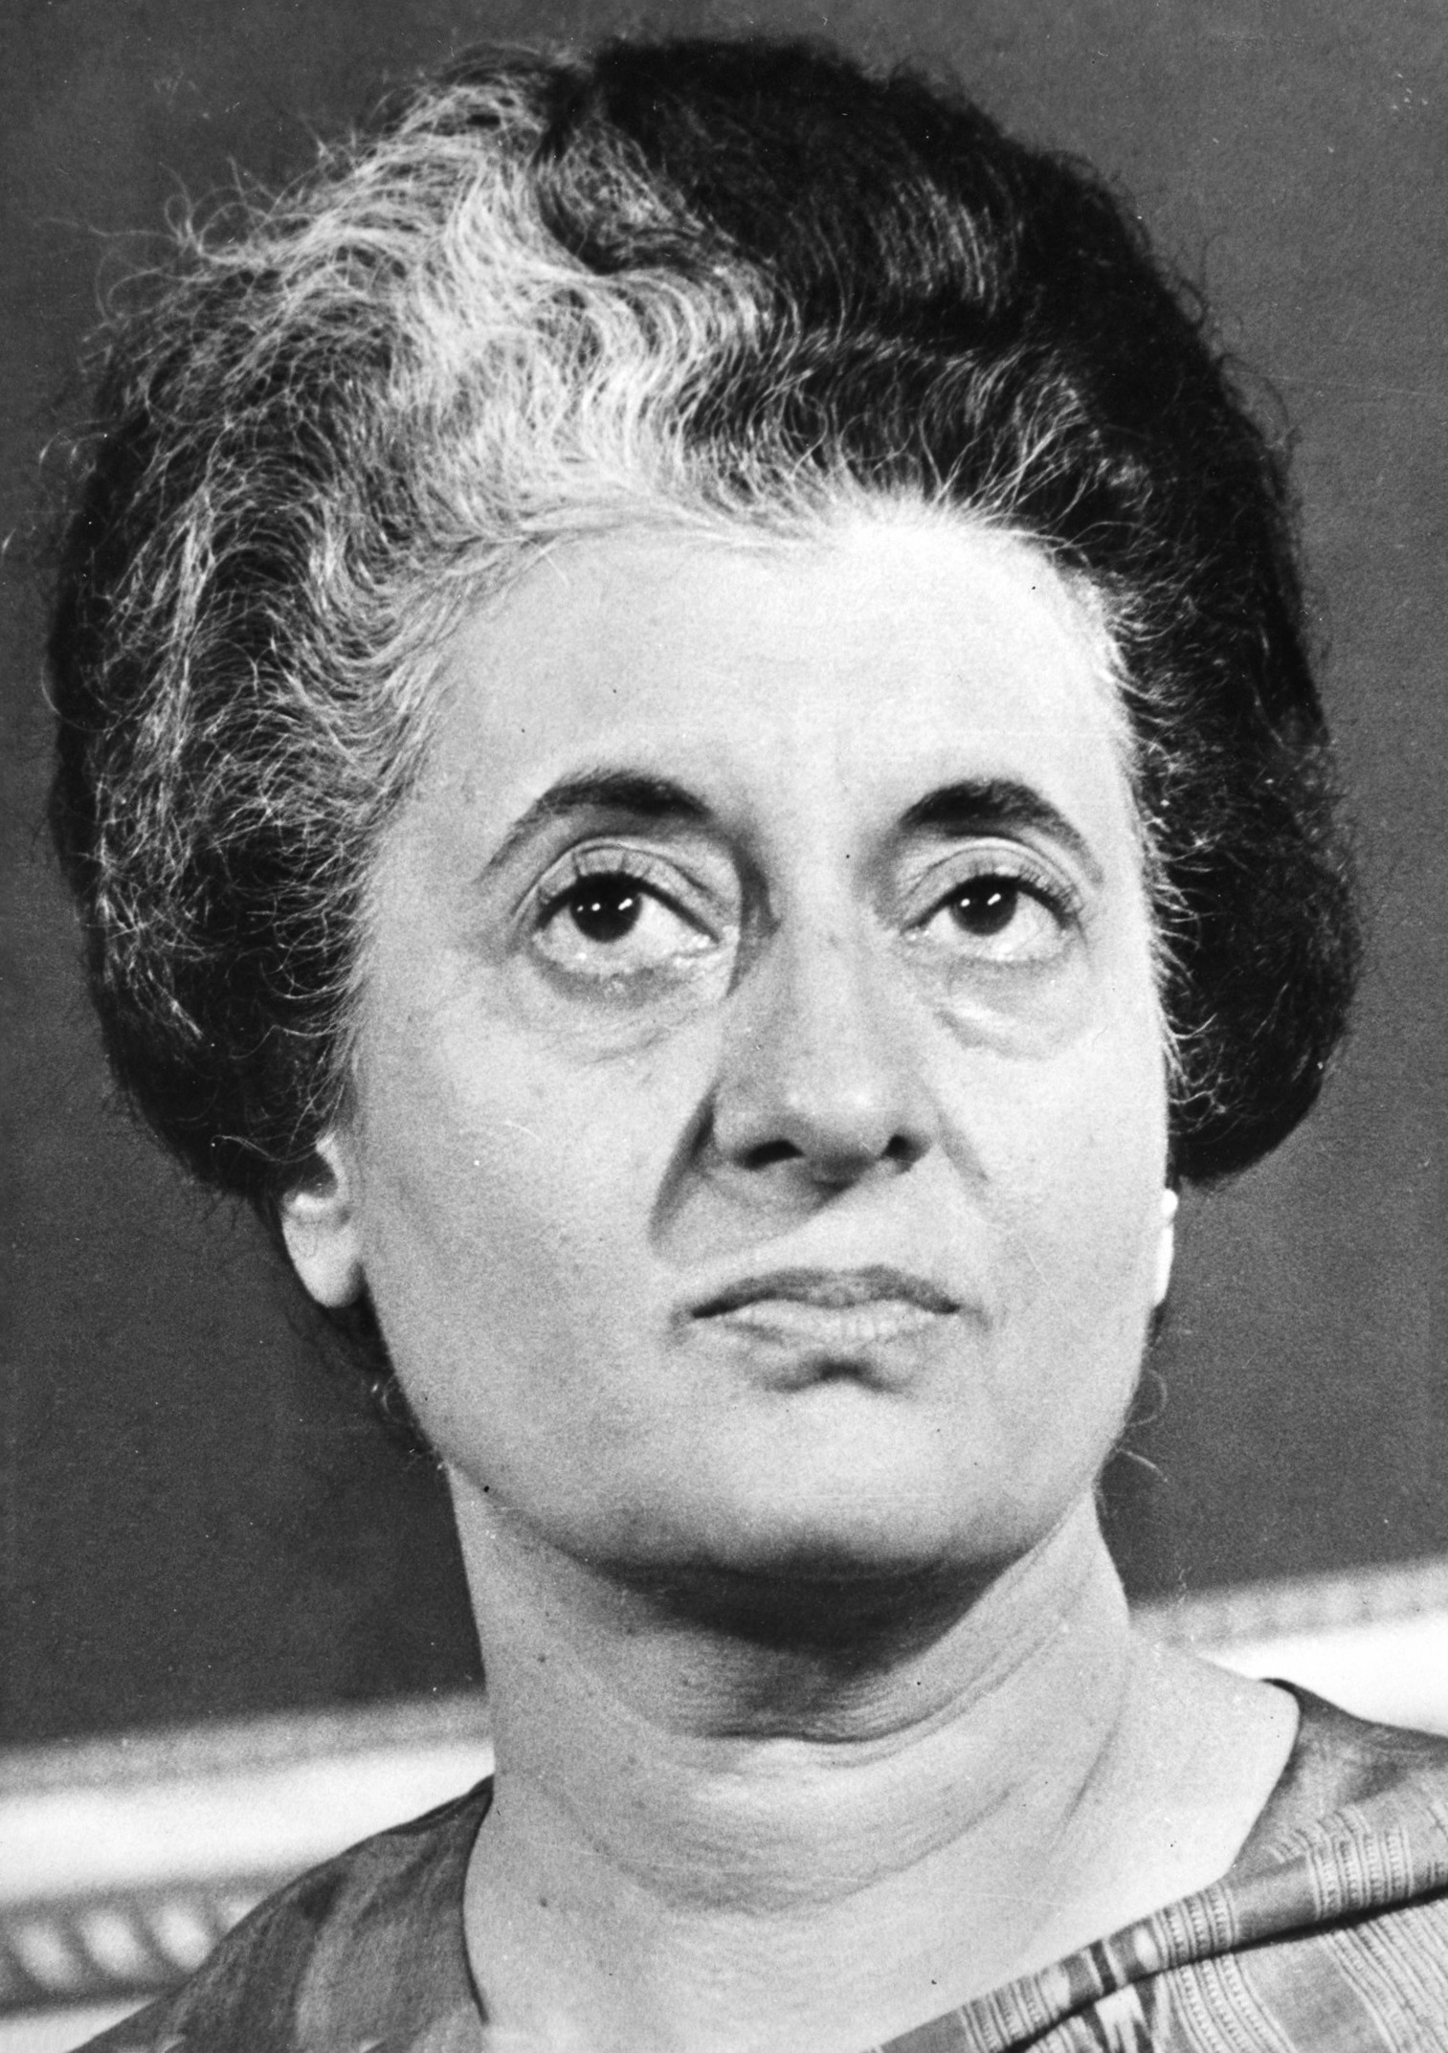 | 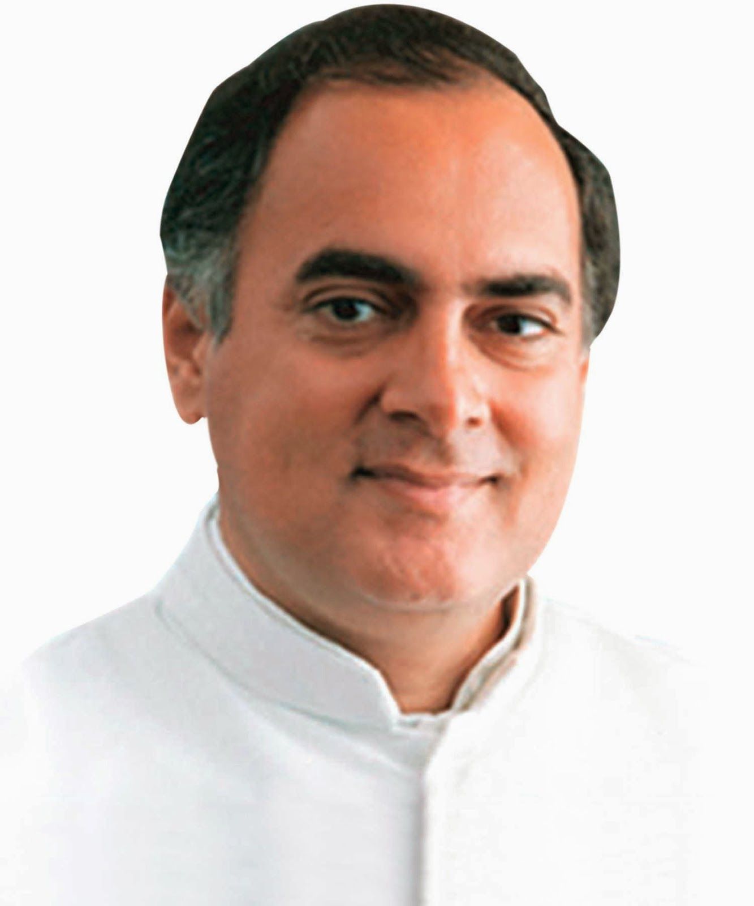 | 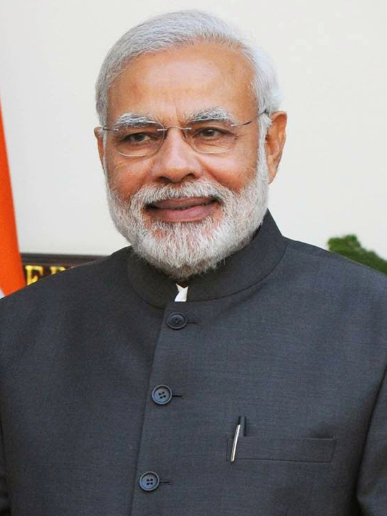
Mahatma Gandhi  (1869-1948) | Jawaharlal Nehru  (1889-1964) | Indira Gandhi  (1917-1984) | Rajiv Gandhi  (1944-1991) | Narendra Modi  (1950-)
[ Congress Party ] | [ Congress Party ] | [ Congress Party ] | [ Congress Party ] | [ BJP ]

